Documentation of Deploymet Wechat

- Do docker hub login on terminal
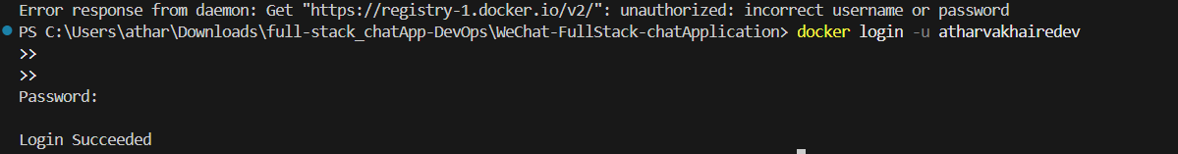
- Start minikube
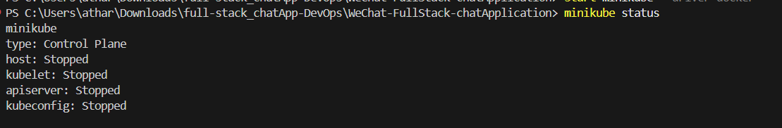
- Created k8s folder for all kubernates yaml configurations
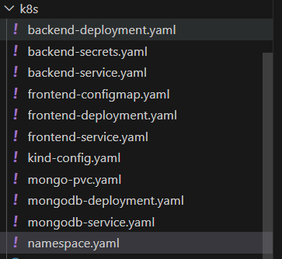
We need all this configuration.

- Create build of frontend and backend both and push image to dockerhub
- Running all deployments , services for backend , frontend and mongodb
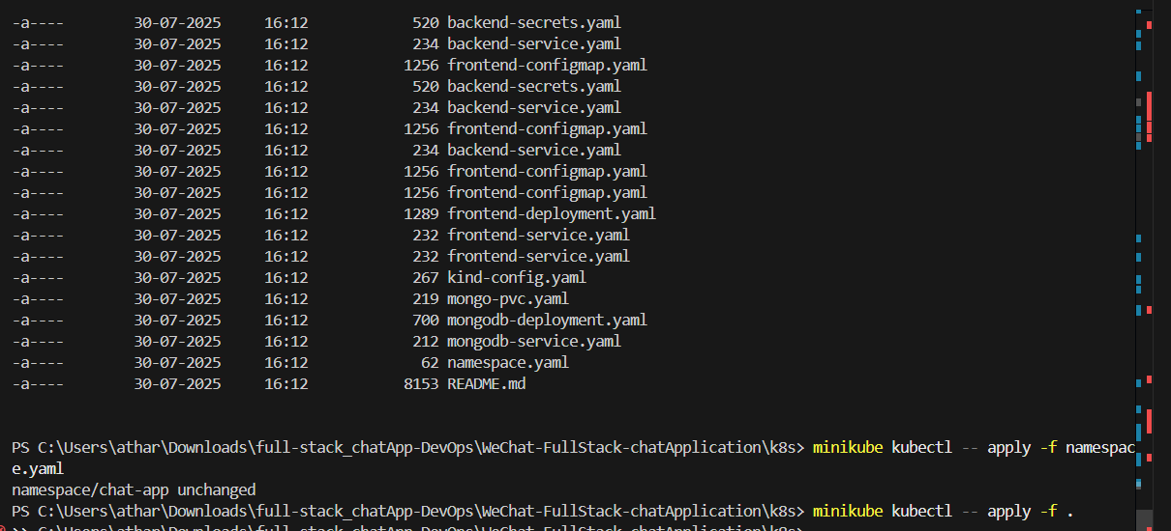

- Now all pods are running
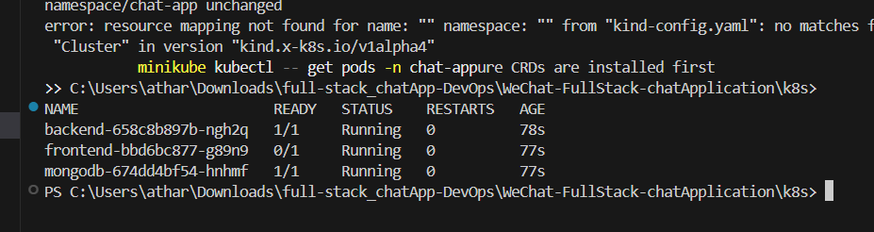

Look like this
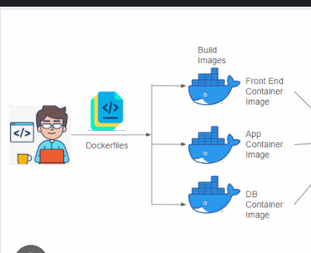

- kubectl port-forward svc/backend 5001:5001 -n chat-app
- kubectl port-forward svc/frontend 8080:80 -n chat-app

- kubectl port-forward svc/mongodb 27017:27017 -n chat-app

